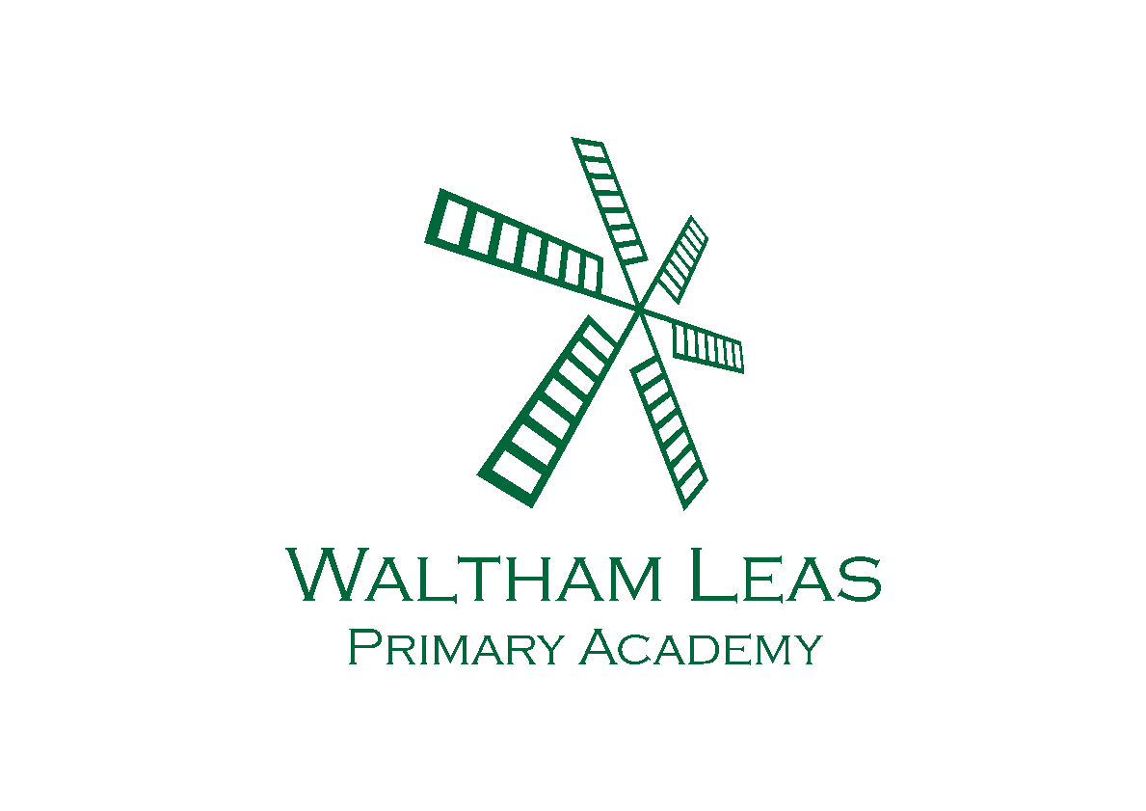
Summer Term
Overview
Year 4
Topic Overview – Year 4
Topic title : Victorian Cleethorpes  Key question: Would Edward Watkins recognise Cleethorpes today? | Term: Summer term 2025  Otter Class - Miss Paton  Wolf Class - Miss Todd
Curriculum Opportunities  Art and Design  Festival Feasts  Design and Technology  Food for Life  Computing  Programming  Word processing  Literacy  Focus texts: How To Train Your Dragon.  Writing Opportunities:  Poetry  Narrative  Non Chronological report  Balanced argument  Recount  Narrative  History  To place key events on a timeline.  To understand the impact of the industrial revolution and railways on Victorian society.  To know how the railways and Edward Watkin impacted the tourist industry.  To identify key landmarks in Victorian Cleethorpes and consider what Cleethorpes would have been like to visit.  Maths  - Decimals  - Money  - Time  - Shape  - Statistics  - Position and direction | PHSE  Heath and wellness  Physical Education  Athletics  Cricket  OAA  Rounders  Science  Sound  Religious Education  Christianity - Why do Christians call the day that Jesus died Good Friday?  Memorable experience(s)/Innovate task  - Back to Bear Residential
How parents can help
- Listen to your child read and ask lots of questions to check understanding.
- Practice spellings - encourage your child to practise using them in sentences.
- Practise times tables.
- Encourage children to discuss what they have done at school, using the Class Dojo page as a starting point. We would love to see comments on the posts on Class Story.

Homework Menu – YEAR 4 – Summer
Victorian Cleethorpes
Complete 5-6 tasks for Bronze level, 7-8 tasks for Silver and all 9 for Gold.
Options on the menu in red, are expected to be completed weekly
Please put all tasks in your homework book and tick off on this sheet when completed. Bring the book back during the last week of term when we can share everything with the class. Thank you!
D&T - prepare your own recipe and include some of the cutting techniques learnt. | Maths – Create a shopping list with all of the items that are a want, need or essentials.  Make a clock out of a paper plate with moving arms. Practice telling the time to the nearest 5 minutes. If you do well, have a go at telling the time to the nearest minute. | PSHE - Create your own gratitude journal for a week. Record things that you are thankful for. Some ideas to structure your thoughts could include:  - 3 wonderful things that happened today are …  - Tomorrow I am looking forward to …  - Something that made my day is … .
Literacy- Create your own diary entry recording how dragon training is going. Try to use all of the features learnt over this term. | Reading - Read a book to somebody at least 3 times a week. Write it in your reading record and comment on what you have read. | Spelling - Keep practising the spellings from your spelling list. Try writing them in different colours, funny writing or playing bingo with them.  Eyes Down!
Science – Create your own experiment to see how sound is produced by vibration. An idea of an experiment:  Use cling film and rice over a glass and then play a musical instrument to observe how the rice moves. | Complete 10 minutes of spelling shed and TTRockstars twice a week. | History - Research an aspect of Victorian life that interests you.  You might want to find out more about:  - Queen Victoria  - The industrial revolution  - Life as a victorian child  - The railway in Britain  - Victorian seaside experiences  - Victorian food and drink  - Victorian clothes  - School life in the Victorian times  - Victorian entertainment

