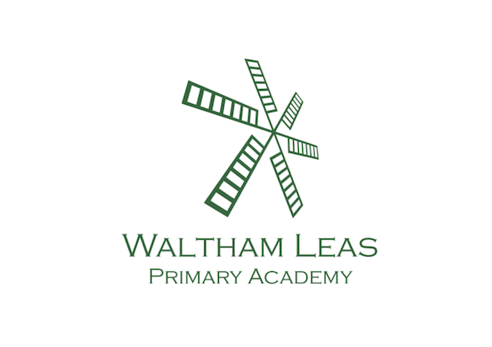

Waltham Leas Primary Academy MFL

What is MFL to us?

MFL to us is all about fostering a natural curiosity about the wider world and developing an enthusiastic and positive attitude when learning another language. We believe that the learning of another language gives children a new perspective on the world, promotes global citizenship and encourages them to understand their own culture and that of others. We aim to ensure that pupils of all abilities develop solid foundations in the key language learning skills: Speaking, Listening, Reading, Writing and Grammar, properly preparing them for the next stage of their language learning journey. These skills will develop children’s ability to understand what they hear and read and enable them to express themselves in
speech and writing. We will extend their knowledge of how language works and explore the similarities and differences between the foreign language they are learning and English.

Context of Waltham Leas

Our main feeder school teaches French to children of all abilities and we have set up good links with them to ensure we provide a sound basis for Secondary school MFL learning. Waltham Leas follows the National Curriculum objectives set out for French for KS2. We encourage a positive attitude towards being able to speak another language and really celebrate our EAL children. At Waltham Leas we use the Language Angels scheme to teach our French lessons, alongside our weekly whole school greetings. We believe that you learn a language better by incorporating it into everyday life, rather than having just a ‘Spanish and vanish’ style lesson.

Intent:

- begin to understand French and communicate in it, using it in everyday life asking and responding to questions (weekly greetings).

- practise and reinforce what they learn so that they leave our school confident in using and understanding a large bank of basic vocabulary and greetings (not just a ‘Spanish and Vanish’ lesson!).

- use their knowledge of French with growing confidence, both to understand what they hear and read, and to express themselves in different ways

- help them develop and demonstrate substantial progress in the 5 key language skills necessary for learning French: Speaking, Listening, Reading, Writing and Grammar.

- make comparisons between languages (celebrating languages spoken in our school)

- learn about different countries and their people, increasing their awareness of other cultures.

- acquire, through all of the above, a sound basis for further study at Key Stage 3 and beyond.

Implementation

French speaking is celebrated as part of our everyday life at Waltham Leas and our MFL curriculum has been designed so that skills and knowledge are built on and continually reinforced.

We implement the French Curriculum in the following ways:

- Language Angels scheme of work- French is taught in a whole-class setting by the class teacher. Teachers plan their lessons using the Language Angels scheme of work and can supplement this with their own ideas and experience. The lessons are designed to motivate, captivate and interest children from the first moment. They have clear, achievable objectives and incorporate different learning styles. SEN children have access to the curriculum through variation of task, grouping or support from an adult. Each class has a timetabled lesson of approximately thirty minutes per week. Each lesson will focus on a combination of the 5 key language learning skills (speaking, listening, reading, writing and grammar). French can also be revisited in short sessions throughout the week to consolidate knowledge and ensure new language is retained.
- Our school’s weekly French greetings are reinforced from FS through to year 6, which ensures that the children have a really solid understanding of key phrases by the time they leave us. Greetings of the week are displayed on doors around the school, used on a day to day basis around school (such as answering the register).
- Sometimes instead of a greeting we have a weekly challenge for the children to do.
- Animal class names displayed on doors in French and mini challenges set to learn them as part of the weekly greetings plan.
- From KS2 children label their exercise books with the French subject name alongside the English.
- From year 3 teachers write the date in English and French every morning on the board (using a laminated or electronic French calendar as a guide). From the Summer term in KS2 teachers introduce the weather as part of their daily calendars.
- In KS2 children write the dates in their books sometimes in French.
- We work with our feeder school to try to plan days in which their language department visits us to put on an event, or our year 6 children visit them for an extra transition day (eg to take part in their Bastille Day).
- We have the Language Angels app which KS2 children can also access at home.
- We have incorporated a variety of MFL themed books into our reading scheme such as dictionaries, French stories, comics and stories about different cultures and countries.

Assessment and progression

Where appropriate worksheets completed by the children are kept in their books which becomes a portfolio of their learning. Two forms of assessment are available at the end of every Language Angels unit:
1. Peer and self-assessment ‘I can do…’ grids. A quick and easy way for all pupils in the class to record which units they have completed and the progress they are making.
2. More detailed skills based assessments using bespoke skills assessment worksheets. This form of assessment enables us to determine the learning and progression of all pupils in the key language learning skills as well as monitoring their progress against the 12 attainment targets stipulated in the DfE Languages Programme of Study for Key Stage 2.

We believe that lots of repetition and consolidation is key to having a solid understanding of a language, so our weekly greetings follow the same cycle each year. The subject leader monitors weekly greeting knowledge during subject walkthroughs.

MFL Curriculum Planning
Our whole school approach to language teaching and learning is in line with the recommendations of the National Curriculum and the requirements outlined in the Department for Education Languages Programme of Study for Key Stage 2.

Impact

The impact of our MFL curriculum can be seen in a variety of ways. From using the weekly greetings to counting in French as part of a maths lesson, people visiting our school will be able to see children speaking French on a daily basis right through from FS up to Year 6. From KS2, they will see the date written on every board in French and see KS2 children confidently writing the date in French in a variety of their exercise books. By the end of year 6 all of our children will have been taught French numbers, at least 14 animal names, some classroom objects, class subject names, the weather and a variety of greetings. They will be able to confidently hold a conversation in French involving 3 or 4 exchanges and be able to write some French words and phrases. They will be passionate, curious and confident about their own foreign language learning abilities when they finish the primary school phase of their education. Our EAL children will feel valued and proud of their ability to speak another language and all children will be aware of other countries, cultures and languages.

Inclusion in our MFL curriculum

The lessons are designed to motivate, captivate and interest children from the first moment. They have clear, achievable objectives and incorporate different learning styles. SEN children have access to the curriculum through variation of task, grouping or support from an adult. French forms part of the school curriculum policy to provide a broad and balanced education to all children. We strive hard to meet the needs of those pupils with special educational needs, those with disabilities, those with special gifts and talents, and those learning English as an additional language, and we take all reasonable steps to achieve this. We believe that our method of teaching using lots of repetition and consolidation (with greetings repeated from FS to year 6) gives every child the best opportunity to solidly retain them. We also believe that by speaking French in everyday life, from FS means that it becomes natural and relevant to the children.

Links outside school
We encourage children to share their experiences of visiting or living in other countries, and we celebrate our EAL children through our ‘languages celebration’ day. We make full use of the internet to find out about life in other countries.

