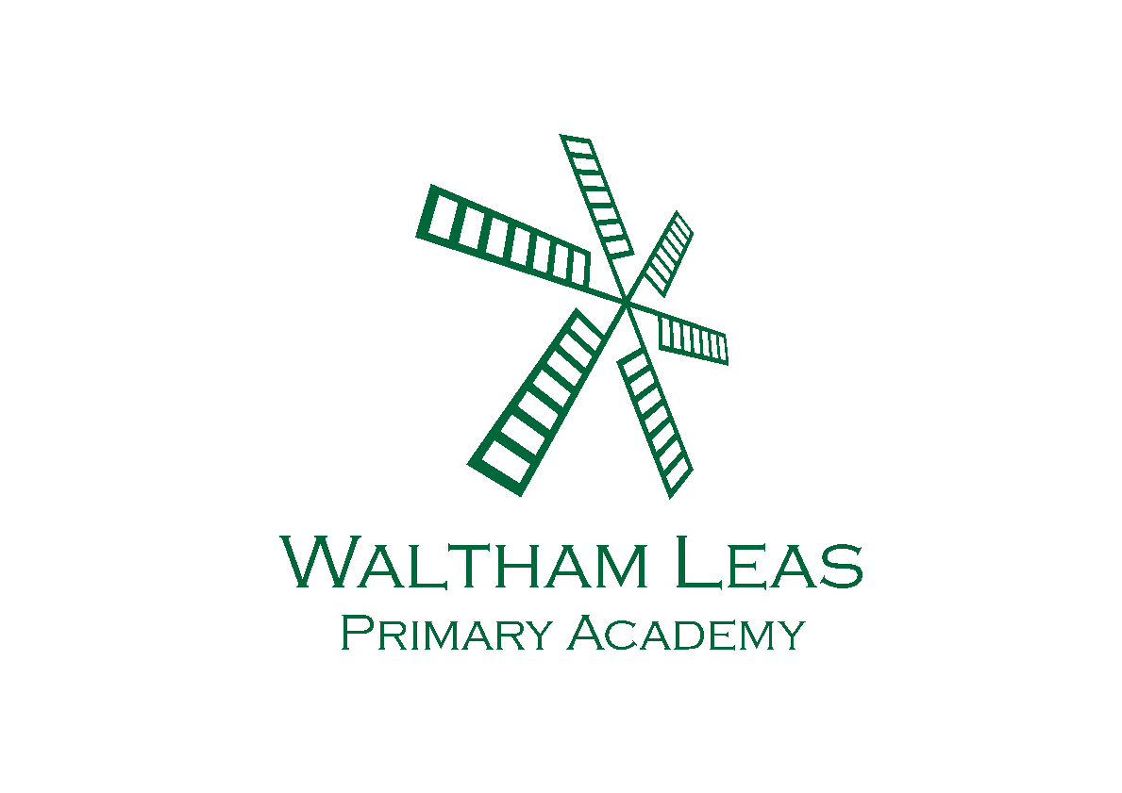
Autumn Term
Overview
Year 5
Topic Overview – Year 5
Topic title: Marvellous Mountains and the Anglo-Saxons | Term: Autumn Term 2026  Teachers:  Chimp Class – Miss Connell  Jaguar Class – Miss Todd
Curriculum Opportunities  Literacy  Focus text:  The Last Wild - Piers Torday  Writing  - Newspaper/ Blog report  - Poetry  - Balanced Argument  - Biography  Maths  - Place Value  - Addition  - Subtraction  - Multiplication  - Division  - Fractions  - Money  Science - Properties and Changes of Materials  - Compare and group everyday materials  - Uses of everyday materials  - Solids, liquids and gases  - Dissolving, filtering, sieving and evaporating  - Reversible and irreversible changes  History - The Anglo-Saxons  - Life in 4th Century Britain and why did the Anglo-Saxons settle in Britain?  - How was Anglo-Saxon Britain ruled?  - How did England change through the settlement of the Anglo Saxons and Vikings?  Geography - Mountains  - Mountain ranges  - Features of mountains  - Identifying UKs largest mountains  - The Himalayas and tourism  Music  - Ukulele  - Livin’ on a Prayer | Art and Design  - Monotype Prints  Design Technology  - Food - making a salad  Computing  - Strategic searching online  - Online Safety  - Scratch programming  PSHE  - Healthy friendships  - Equality and discrimination  Physical Education  - Yoga  - OAA  - Tag Rugby  - Netball  Religious Education  - What does it mean if Christians believe God is Holy and loving?  - What does it mean to be a Muslim in Britain today?  Memorable experiences/Innovate task  Maths Week Entrepreneur Tasks  Christmas Carol Service
How parents can help

- Listen to your child read at least 3 times a week and ask lots of questions to check understanding.
- Encourage your child to practise their common exception words from the Year 5/6 Spelling List
- Encourage your child to regularly practise their times tables on Times Tables Rock Stars.
- Encourage children to discuss what they have done at school, using the Class Dojo page as a starting point.

Homework Menu – YEAR 5 – Autumn
Complete 5-6 tasks for Bronze level, 7-8 tasks for Silver and all 9 for Gold.
Options on the menu in red are expected to be completed weekly.
If you complete any of the options on the menu in black please upload evidence of the work onto Google Classroom or bring in a paper copy.
Thank you.
Geography - Mountain Fact File – Choose a famous mountain . Create a fact file including where it is, how high it is, how it was formed and three interesting facts. | Maths – Practise your times tables on TT Rock Stars and see if anyone at home can challenge you with your mental maths. | Art - Design a Shield – Design and colour an Anglo-Saxon shield. Label the colours, symbols and explain why you chose them.
Spelling – Practise your Year 5/6 Spelling List. Use a piece of paper to practise them and try putting them into sentences. | DT – Recipe Designer – Invent your own Anglo-Saxon-inspired meal. Include ingredients, equipment needed and explain why people would enjoy eating it. | Reading - Read your book to somebody at least 3 times a week. Record your reads in your reading diary.
Science – Explore changes in materials at home e.g. melting, dissolving, cooking.  (Ask your parents before carrying out this activity). | Literacy - Write an acrostic poem about a woodland animal.  Write a diary entry about your day, as if you were an Anglo-Saxon. | Computing - Mini Documentary – Create a short video about a hobby, pet or favourite place. Include a beginning, middle and ending.

